Billingham ASC Sponsored Clean Up
Saturday 13th April 2019 Preston Park
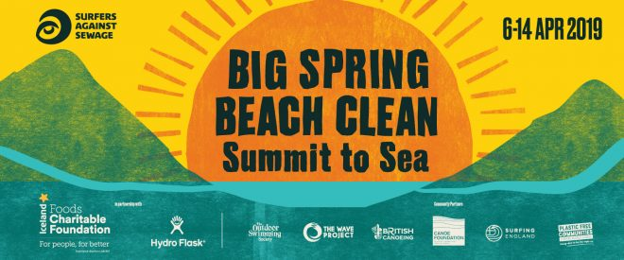

NAME | AMOUNT | PAID

